# Standard DICOM

## DICOM datotetka:

Dodeljena mi je bila datoteka *»image01.dcm«.*

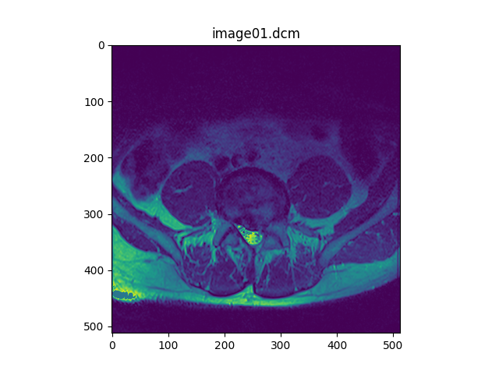

## Get DICOM tag name

import csv

import numpy as np

dcmGroupsname = "dcmGroups.csv"

dcmGroups = np.loadtxt(dcmGroupsname, delimiter=";", dtype=str)

dcmElementsname = "dcmElements.csv"

dcmElements = np.loadtxt(dcmElementsname, delimiter=";", dtype=str)

def getDicomTagName(iTag):

    iTagG = iTag[:4]

    iGroupn = dcmGroups[:,0]

    for i in range(np.size(iGroupn)-1):

        if iTagG == iGroupn[i]:

            oGroupName = dcmGroups[i, 1]

    iElements = dcmElements[:,0]

    for n in range(np.size(iElements)-1):

        if iTag in iElements[n]:

            oElementName = dcmElements[n, 1]

    return oGroupName, oElementName

## Podatkovni elementi

|  |  |  |  |  |  |  |  |
| --- | --- | --- | --- | --- | --- | --- | --- |
| **Index** | **Skupina** | **Podskupina** | **Predstavitev vrednosti** | **Dolžina** | **Vrednost** | **Skupina2** | **Element** |
| {'idx': 584 | 'teg': '0008 | 0023' | 'VR': 'DA' | 'VL': 8 | 'value': '20120516' | 'group': 'Study Information' | 'element': "'Image Date'"} |
| {'idx': 666 | 'teg': '0008 | 0033' | 'VR': 'TM' | 'VL': 14 | 'value': '172932.609000 ' | 'group': 'Study Information' | 'element': "'Image Time'"} |
| {'idx': 1414 | 'teg': '0010 | 0010' | 'VR': 'PN' | 'VL': 12 | 'value': 'Ime Priimek\x00' | 'group': 'Patient Information' | 'element': "'Patient''s Name'"} |
| {'idx': 1534 | 'teg': '0010 | 1010' | 'VR': 'AS' | 'VL': 4 | 'value': '052Y' | 'group': 'Patient Information' | 'element': "'Patient''s Age'"} |
| {'idx': 2602 | 'teg': '0028 | 0010' | 'VR': 'US' | 'VL': 2 | 'value': 512 | 'group': 'Image Information' | 'element': "'Rows'"} |
| {'idx': 2726 | 'teg': '0028 | 1051' | 'VR': 'DS' | 'VL': 4 | 'value': '690 ' | 'group': 'Image Information' | 'element': "'Window Width'"} |
| {'idx': 600 | 'teg': '0008 | 0030' | 'VR': 'TM' | 'VL': 14 | 'value': '170532.015000 ' | 'group': 'Study Information' | 'element': "'Study Time'"} |

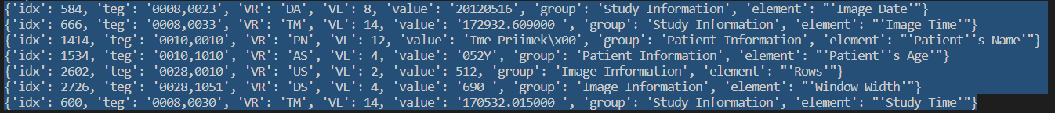

## Podatki o datoteki:

1. Datoteka je velika 579KB.

## Naslov do Github repota:

<https://github.com/Cyclocyclone/BiotehniskaInformatika/tree/main/Vaja_03>